2)window Object

The window object represents a window in browser.

An object of window is created automatically by the browser.

methods:

1)alert()

2)confirm()

3)prompt()

eg:

window.alert();

OR

alert();

Note:

Window is the object of browser, it is not the object of javascript. The javascript objects are string, array, date etc.

**Methods of window object**

**prompt():**

var variable=prompt("Input Message","default value")

default value is optional....

if we don't use default value and value is not enter(type) and

click on OK button...then undefined(empty) value is display

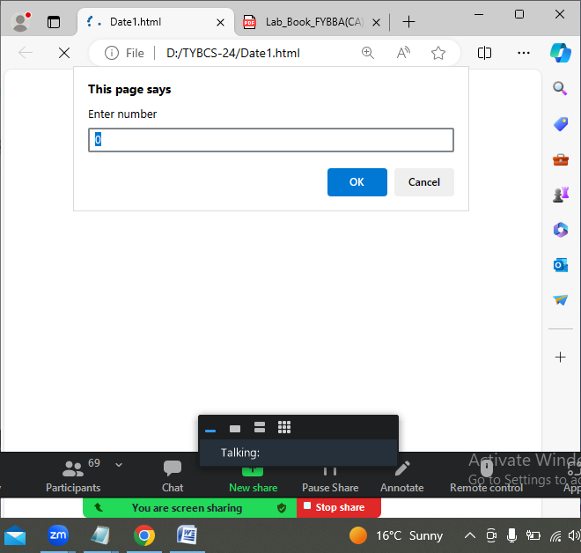

It has -

one label(message)

one input field

two buttons ie ok and cancel...

prompt dialog box accept values in String format...

eg:

1)accept number in string format

var n=input("Enter number:")

2)Convert number into int :

n=parseInt(n)

2)Convert number into float :

n=parseFloat(n)

alert():

It Display Message.

It is Output Dialog box.

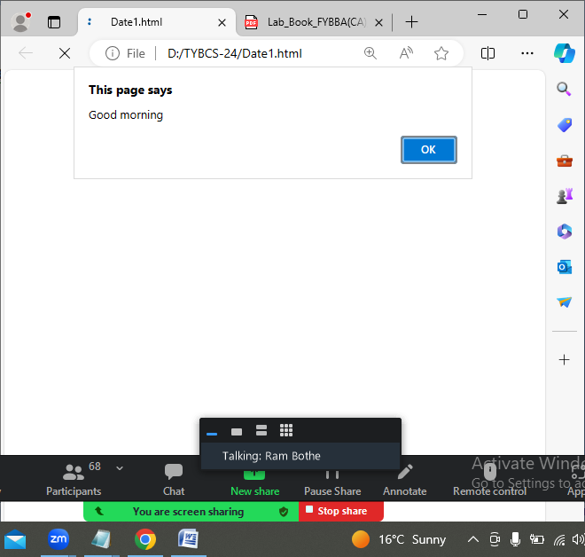

It has One Label Mssage..and only one button ie.OK

Eg:

alert(“Good Mrning”);

3)confirm():

It is used to display confirmation message…

confirm() displays the confirm dialog box containing message with ok and cancel button.

When Click OK: then return true.

When Click Cancel: then return false.

Eg:

var f=confirm("Are u sure?");

if(f==true)

{

}

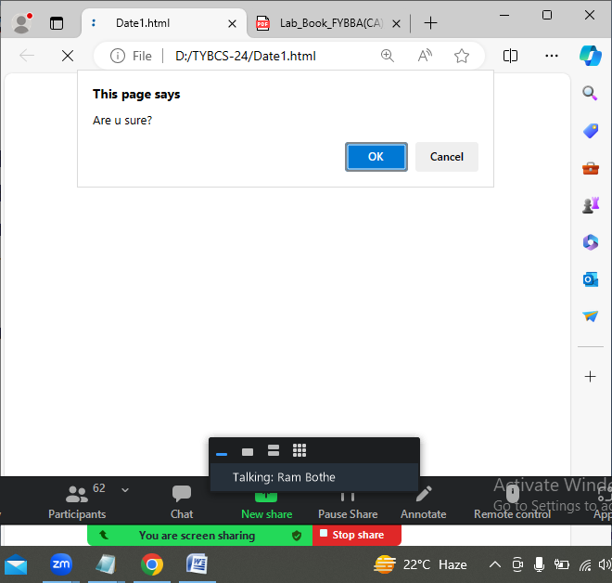

<script>

var f=confirm("Are u sure?");

if(f==true)

{

var n=prompt("Enter number:");

var s=n*n;

alert("Square="+s);

}

</script>